Steps for Importing the Package into Bb

1. Save the attached zip file to your computer
2. On the course menu, navigate to the **Packages and Utilities** section and then click **Import Package/View Logs**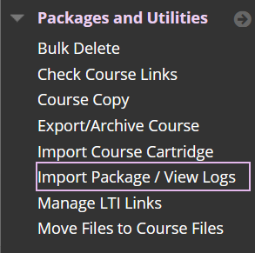
3. Click the **Import Package** link and locate the zip file you saved in step 1.  
   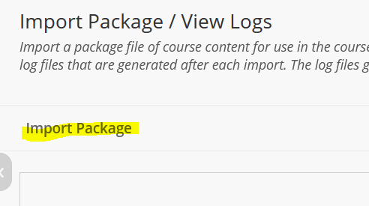
4. On the import screen, click the **Browse Local Files** button and locate the zip file.   
   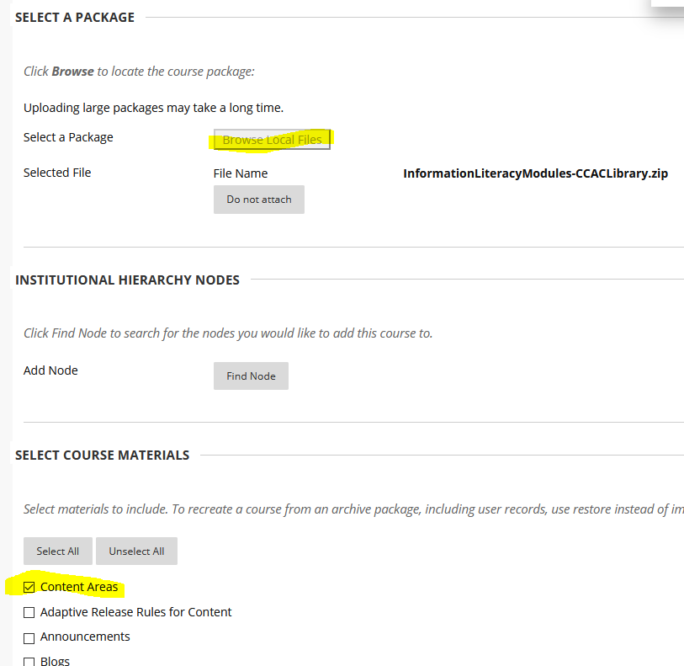
5. In the **Select Course** Materials area, place a check in the **Content Areas** box and then click the **Submit** button.  
   
6. After the import finishes, which should only take a few seconds, refresh your browser and you should see an **Information Literacy** link on the course menu.   
   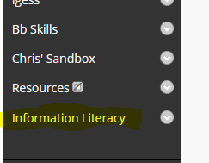

From there you can navigate the explore the modules.

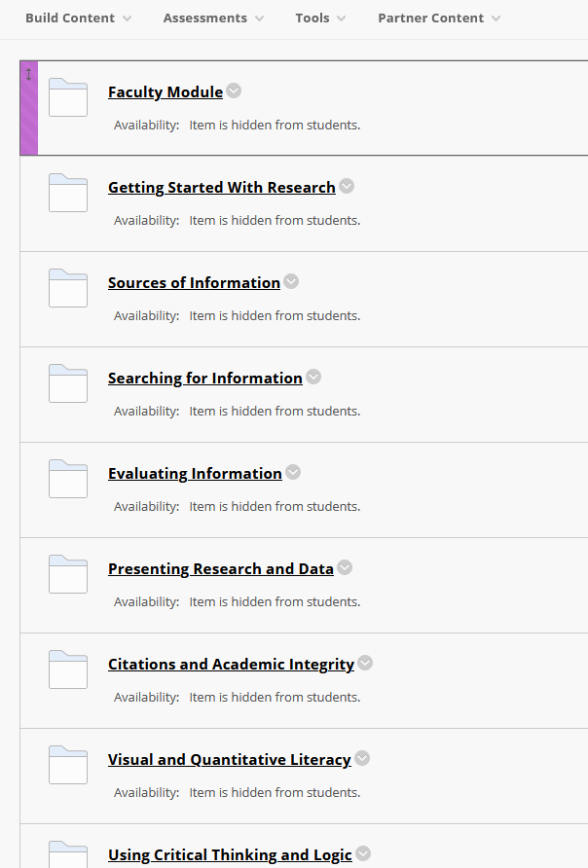

Modules are all unavailable to students by default, so you can enable the ones you want.  
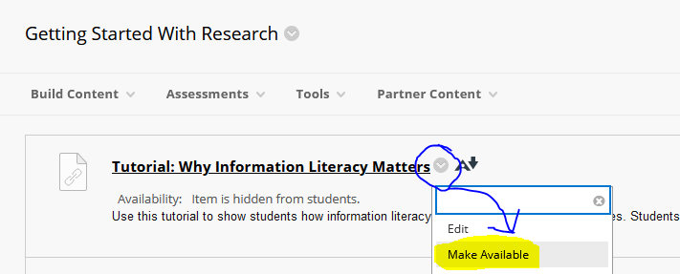

A point value can be assigned to these on an individual basis. To do that, edit an item and set the Enable Evaluation section to **Yes** which will allow you to set a point value for the gradebook and set a due date.

